Student Name: Xianglong Lin Student Number: 45791439 Team Name: H2OMG
Week: _8_
Title: Balancing Utility and Enjoyment in Water Conservation through the Four Pleasures
Description:
In the 8th week, I began to try to incorporate user experience (UX) into prototype design based on the prompts in the studio material. According to the feedback from the tutors of last week's Design Exhibit of Iteration 1, the development of the front-end interface had been started to achieve user interaction and data visualisation for water resource projects. Although the Arduino-based water flow sensor is effective in collecting and presenting raw data, a more user-friendly and actionable form is even more important. Therefore, while conceiving the layout and interaction flow of the high-fidelity prototype, I consciously focused on application notifications and customised water-saving suggestions based on real-time data. In addition, I also applied Patrick Jordan's Four Pleasures to the project during the studio in order to ensure that the functionality of the prototype would be practical, and the user interface would be intuitive and effective.
Visual Evidence:
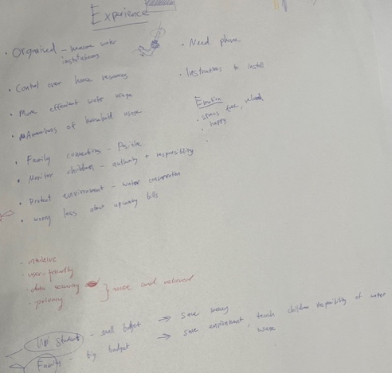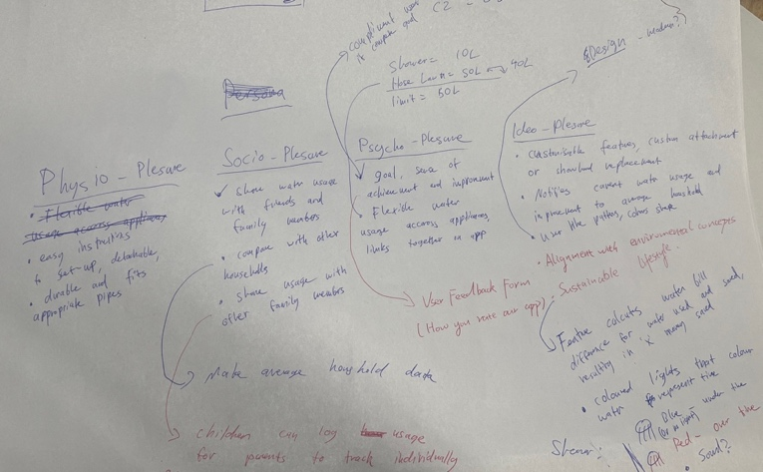
Statement on Learning:
This studio focused on improving user experience through usability and emotional engagement. Based on the feedback from Exhibit 1, although my prototype demonstrated satisfied performance on the technical level, users might have difficulty understanding the meaning of the data in an effective and intuitive form. Therefore, it was necessary to adopt a user-centred design approach at this moment, especially in terms of clarity, intuition, and operability of the user interface. As I iterate from low-fidelity prototype to high-fidelity prototype, the front-end prioritises ensuring that users visually receive reasonable and meaningful information notifications instead of simply displaying data analysis charts. For example, the app proposes specific suggestions for shortening water usage time or changing water usage habits based on water volume values, which will also directly support users' goal of saving water.
On the other hand, the analysis of Four Pleasures on this project led me to further optimise and iterate the design from an emotional and social perspective. In terms of physio-pleasure, I design and create visually intuitive and user-friendly front-end interfaces for a more positive sensory experience; In terms of socio-pleasure, I plan to enable users to share water-saving achievements with friends and family, promoting social experience and enhancing collective pride and responsibility for sustainability; In terms of psycho-pleasure, users not only get clear and effective suggestions from the app on water conservation, but also gain a sense of accomplishment when approaching and achieving water conservation goals; In terms of ideo-pleasure, the system concept of the app is highly consistent with the user's aim of saving water and protecting the environment, allowing users to feel that they have contributed their own strength to environmental protection.
This balanced approach had profound significance for both system functionality and user experience. Once the front-end interface is completed, more user tests will be conducted to improve these aspects and achieve the project's satisfaction with diverse needs. This also stood for the foundation of my user interface in meeting users' actual needs and evoking emotional resonances from data to user-friendly actionable insights.

